

AP® Physics C
2002 Free response Questions

The materials included in these files are intended for use by AP teachers for course and exam preparation in the classroom; permission for any other use must be sought from the Advanced Placement Program®. Teachers may reproduce them, in whole or in part, in limited quantities, for face-to-face teaching purposes but may not mass distribute the materials, electronically or otherwise. These materials and any copies made of them may not be resold, and the copyright notices must be retained as they appear here. This permission does not apply to any third-party copyrights contained herein.

These materials were produced by Educational Testing Service® (ETS®), which develops and administers the examinations of the Advanced Placement
Program for the College Board. The College Board and Educational Testing Service (ETS) are dedicated to the principle of equal opportunity, and their
programs, services, and employment policies are guided by that principle.

The College Board is a national nonprofit membership association dedicated to preparing, inspiring, and connecting students to college and opportunity.
Founded in 1900, the association is composed of more than 4,200 schools, colleges, universities, and other educational organizations. Each year, the
College Board serves over three million students and their parents, 22,000 high schools, and 3,500 colleges, through major programs and services in
college admission, guidance, assessment, financial aid, enrollment, and teaching and learning. Among its best-known programs are the SAT®, the
PSAT/NMSQT®, and the Advanced Placement Program® (AP®). The College Board is committed to the principles of equity and
excellence, and that commitment is embodied in all of its programs, services, activities, and concerns.

APIEL is a trademark owned by the College Entrance Examination Board. PSAT/NMSQT is a registered trademark jointly owned by the College Entrance Examination Board and the National Merit Scholarship Corporation. Educational Testing Service and ETS are registered trademarks of Educational Testing Service.
2002M1. A crash test car of mass 1,000 kg moving at constant speed of 12 m/s collides completely inelastically with an object of mass M at time t = 0. The object was initially at rest. The speed v in m/s of the car-object system after the collision is given as a function of time t in seconds by the expression
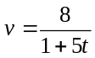
a. Calculate the mass M of the object.
b. Assuming an initial position of x = 0, determine an expression for the position of the car-object system after the collision as a function of time t.
c. Determine an expression for the resisting force on the car-object system after the collision as a function of time t.
d. Determine the impulse delivered to the car-object system from t = 0 to t = 2.0 s.

2002M2. The cart shown above is made of a block of mass m and four solid rubber tires each of mass m/4 and radius r. Each tire may be considered to be a disk. (A disk has rotational inertia ½ ML², where M is the mass and L is the radius of the disk.) The cart is released from rest and rolls without slipping from the top of an inclined plane of height h. Express all algebraic answers in terms of the given quantities and fundamental constants.
a. Determine the total rotational inertia of all four tires.
b. Determine the speed of the cart when it reaches the bottom of the incline.
c. After rolling down the incline and across the horizontal surface, the cart collides with a bumper of negligible mass attached to an ideal spring, which has a spring constant k. Determine the distance x_{m} the spring is compressed before the cart and bumper come to rest.
d. Now assume that the bumper has a non-negligible mass. After the collision with the bumper, the spring is compressed to a maximum distance of about 90% of the value of x_{m} in part (c). Give a reasonable explanation for this decrease.

2002M3. An object of mass 0.5 kg experiences a force that is associated with the potential energy function
U(x) = 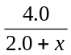, where U is in joules and x is in meters.
a. On the axes below, sketch the graph of U(x) versus x.
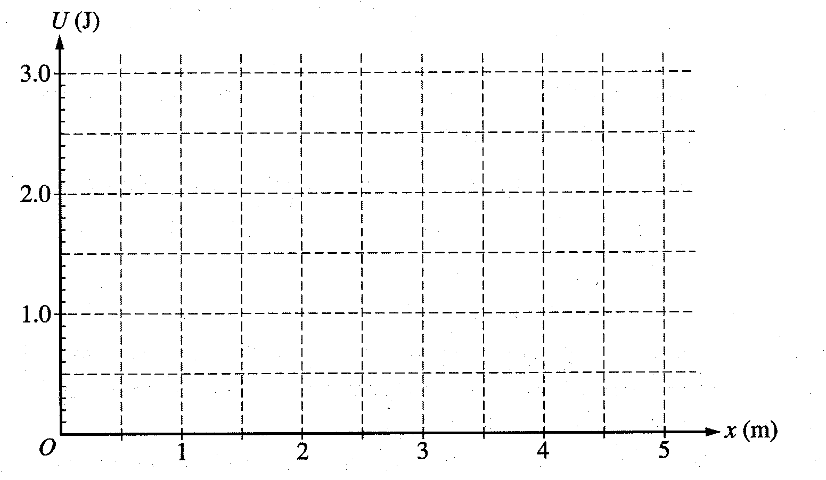
b. Determine the force associated with the potential energy function given above.
c. Suppose that the object is released from rest at the origin. Determine the speed of the particle at x = 2 m.

In the laboratory, you are given a glider of mass 0.50 kg on an air track. The glider is acted on by the force determined in part b. Your goal is to determine experimentally the validity of your theoretical calculation in part c.

d. From the list below, select the additional equipment you will need from the laboratory to do your experiment by checking the line to the left of each item. If you need more than one of an item, place the number you need on the line.

Meterstick _____ Stopwatch Photogate timer String Spring

Balance Wood block Set of objects of different masses

e. Briefly outline the procedure you will use, being explicit about what measurements you need to make in order to determine the speed. You may include a labeled diagram of your setup if it will clarify your procedure.
2002E1. A rod of uniform linear charge density λ = +1.5 x 10⁻⁵ C/m is bent into an arc of radius R = 0.10 m. The arc is placed with its center at the origin of the axes shown above.
a. Determine the total charge on the rod.
b. Determine the magnitude and direction of the electric field at the center O of the arc.
c. Determine the electric potential at point O.

A proton is now placed at point O and held in place. Ignore the effects of gravity in the rest of this problem.
d. Determine the magnitude and direction of the force that must be applied in order to keep the proton at rest.
e. The proton is now released. Describe in words its motion for a long time after its release.

2002E2. Your engineering firm has built the RC circuit shown above. The current is measured for the time t after the switch is closed at t = 0 and the best-fit curve is represented by the equation I(t) = 5.20 e^{-t/10}, where I is in milliamperes and t is in seconds.
a. Determine the value of the charging voltage V_{o} predicted by the equation.
b. Determine the value of the capacitance C predicted by the equation.
c. The charging voltage is measured in the laboratory and found to be greater than predicted in part a.
i. Give one possible explanation for this finding.
ii. Explain the implications that your answer to part i has for the predicted value of the capacitance.
d. Your laboratory supervisor tells you that the charging time must be decreased. You may add resistors or capacitors to the original components and reconnect the RC circuit. In parts i and ii below, show how to reconnect the circuit, using either an additional resistor or a capacitor to decrease the charging time.

i. Indicate how a resistor may be added to decrease the charging time. Add the necessary resistor and connections to the following diagram.
ii. Instead of a resistor, use a capacitor. Indicate how the capacitor may be added to decrease the charging time. Add the necessary capacitor and connections to the following diagram.

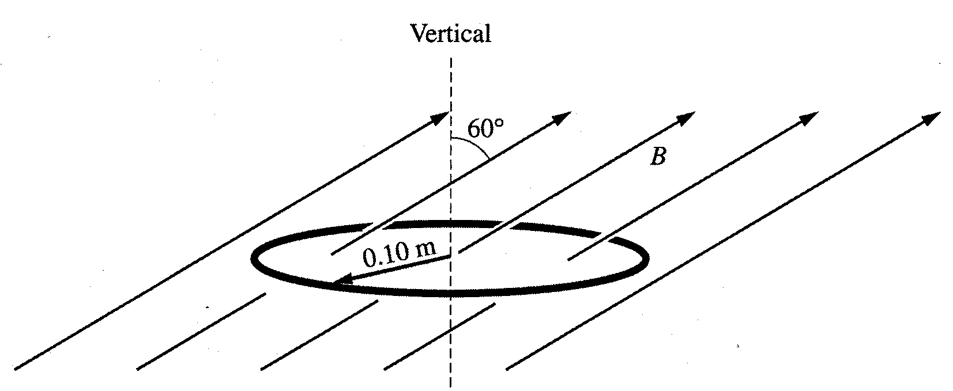
2002E3. A circular wire loop with radius 0.10 m and resistance 50 Ω is suspended horizontally in a magnetic field of magnitude B directed upward at an angle of 60° with the vertical, as shown above. The magnitude of the field in teslas is given as a function of time t in seconds by the equation B = 4(1 - 0.2t).
a. Determine the magnetic flux Φ_{m} through the loop as a function of time.
b. Graph the magnetic flux Φ_{m} as a function of time on the axes below.
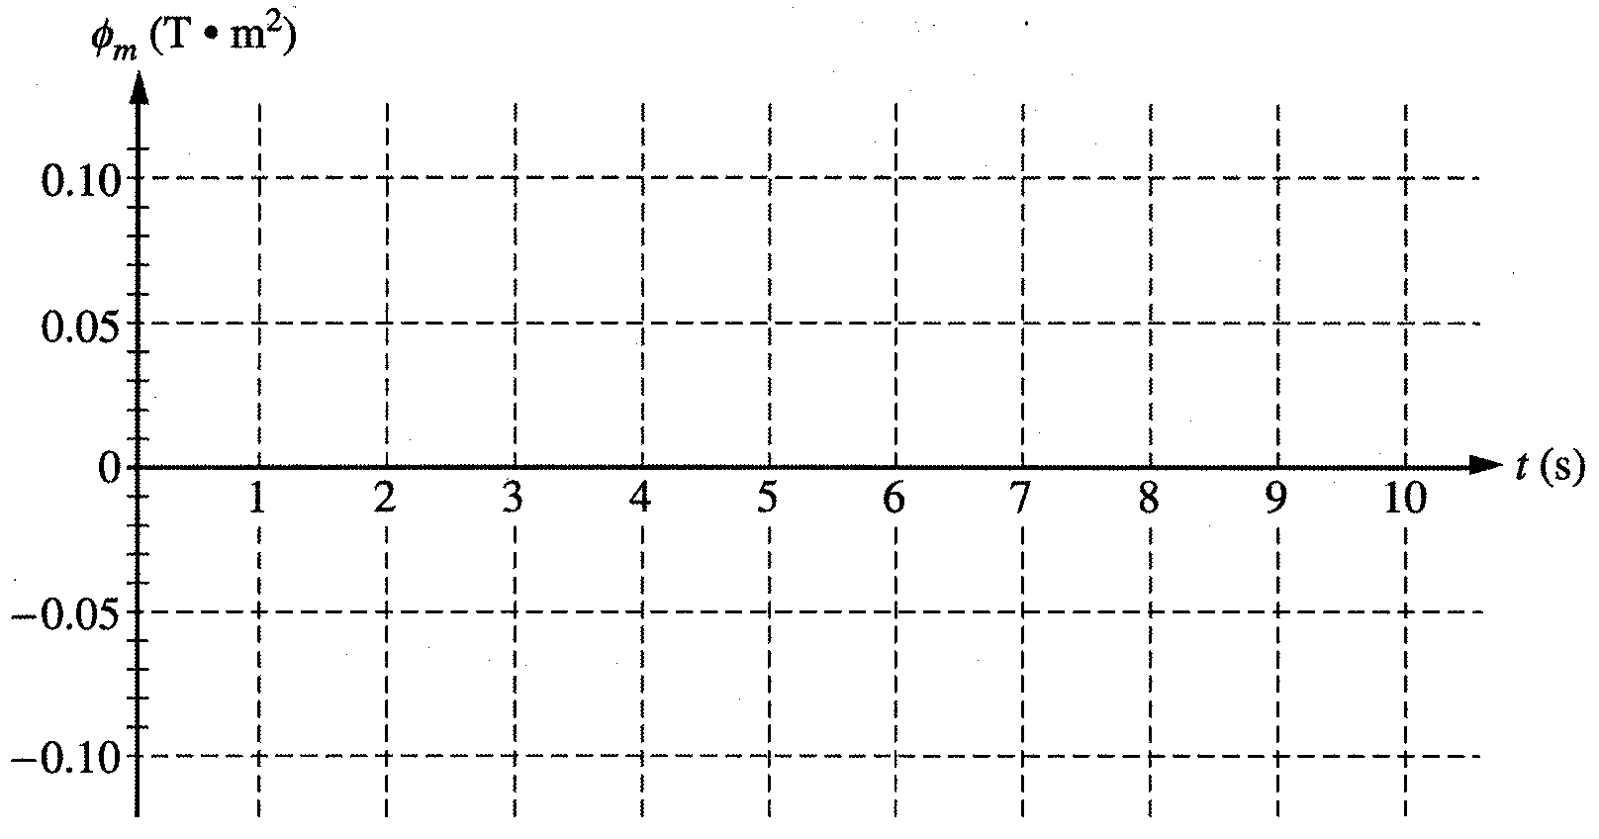
c. Determine the magnitude of the induced emf in the loop.
d. i. Determine the magnitude of the induced current in the loop.
ii. Show the direction of the induced current on the following diagram
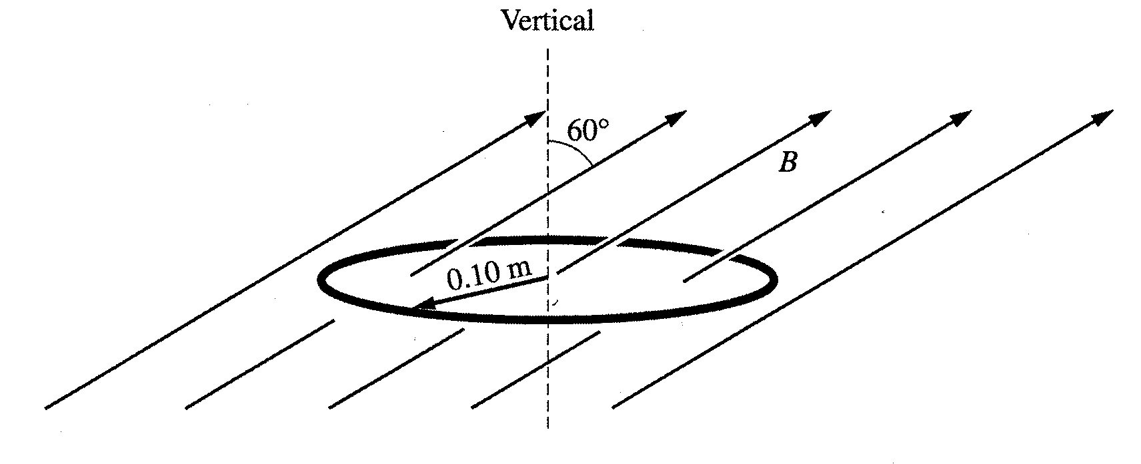
e. Determine the energy dissipated in the loop from t = 0 to t = 4 s

